1) Para que servem os nutrientes?

___________________________________________________________________________

___________________________________________________________________________

2) Diga aonde são encontrados cada uns dos seguintes alimentos:

a) Carboidratos: __________________________________________________________

__________________________________________________________________________

b) Proteínas: _____________________________________________________________

__________________________________________________________________________

c) Lipídeos: ______________________________________________________________

__________________________________________________________________________

d) Vitaminas e sais minerais: _____________________________________________

__________________________________________________________________________

3) Marque as opções corretas:

( ) A água está presente em vários alimentos.

( ) As fibras alimentares são ricas em nutrientes

( ) As fibras alimentares dão consistências as fezes e ajuda na sua eliminação.

( ) As fibras alimentares são encontradas em frutas, hortaliças e cereais.

4) Quais os problemas que uma alimentação não-saudável pode causar?

________________________________________________________________________________

________________________________________________________________________________

________________________________________________________________________________

5) Coloque (O) para as frases relacionadas com a obesidade e (D) para as frases relacionadas a desnutrição.

( ) Causa fraqueza, emagrecimento e facilidade de adoecer.

( ) Pode causar doenças do coração

( ) Adquirida ao consumir alimentos gordurosos

( ) É a falta de nutrientes no organismo

6) Quais as técnicas de conservação dos alimentos

a) Retirar o excesso de água do alimento: ___________________________________

b) Adicionar produtos químicos para conservar o alimento: _____________________________________________________________________________

c) Deixar o alimento em baixa temperatura para matar ou impedir os elementos decompositores: __________________________________________________

d) Ferver o alimento e em seguida resfriá-lo rapidamente: ____________________

7) Escreva os nomes dos orgãos do sistema digetivo

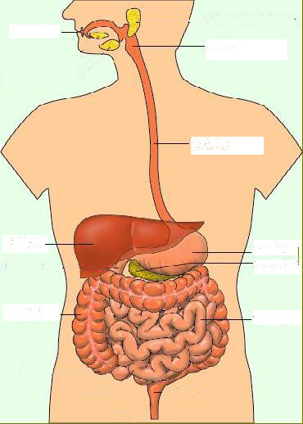

8) O que as glândulas salivares produzem e para que serve?

________________________________________________________________________________

________________________________________________________________________________

9) Qual a função do fígado e do pâncreas?

________________________________________________________________________________

________________________________________________________________________________

10) Escreva todo o caminho que o alimento percorre pelo sistema digestivo.

________________________________________________________________________________

________________________________________________________________________________

________________________________________________________________________________

________________________________________________________________________________